

CENTENNIAL College Progress Campus

COURSE CNET204 Section 061, 062, 063 and 64 Fall 2012

Assignment 3 – Global Citizenship and Equity (GC&E)

Chose a Global Citizenship and Equity Topic from the following GC&E issues:
- Violation of women’s rights in Sharia Law (female mutilation, property rights etc.)
- Rape and Sexual Violence as a tool of war Women Under Siege
- The relationship between illiteracy and denial of women’s rights in Afghanistan or anywhere else there is documented evidence of it.
- Child torture in Syria leading to the civil war that now exists
- The role of education in society and changes needed to promote equity
- Human Rights in China
- Worker’s Rights in China
- Democracy rights in Russia and China and all other dictatorships
- Other Topic of your Choice - if you have come from a violent or oppressive circumstance and you have access to accurate and object information and videos on YouTube® then educate me and your school community to your truth.

Go to http://facutyweb.centennialcollege.ca/bwarne and navigate to the CNET204, Weekly Schedule page and download the Assignment3.rar file that has the images folder with some of the images you need for this assignment. Paste it into H:\CNET204 and right click to choose “Unpack Here”. That will give you the Assignment3 folder you need with the images subfolder in it
Create an HTML web page that includes the following required format:
- A page background gradient image 1920X1080. (I gave it to you in the images folder for this assignment but you can create your own as long as you remember your design rules for look and accessibility). Remember to set the Page Properties for this
- Use PhotoShop® to create a TableBanner.jpg with a 100 pixel height with the UN logo on the left, the Ontario Human Rights Commission logo on the right and a gradient layer using a complimentary color to you PageBackground1920X1080.jpg gradient file. You must create this in PhotoShop® and save it as both a .psd file and a .jpg file in your images folder.
- In row 2 you must use Spry Tabbed Panels with the following Tabs:
  - GC&E Intro
    - Here you must introduce your GC&E issue with What, Where, Who, and Why you chose it and information about your human rights interest
  - Issue Details
    - Here you must give detailed information about your issue using bulleted lists and text.
  - Issue Solutions
    - Documented solutions – United Nations resolutions etc.
    - Your own personal solutions, feelings, hopes and even prayers you might say if you are spiritual

  - Video 1
    - A YouTube video about your issue
  - Video 2
    - Another YouTube video about your issue
  - Information Sources
    - Here you must identify the websites and other sources of information you used

- A copyright with your name and copyright symbol in the third row centered

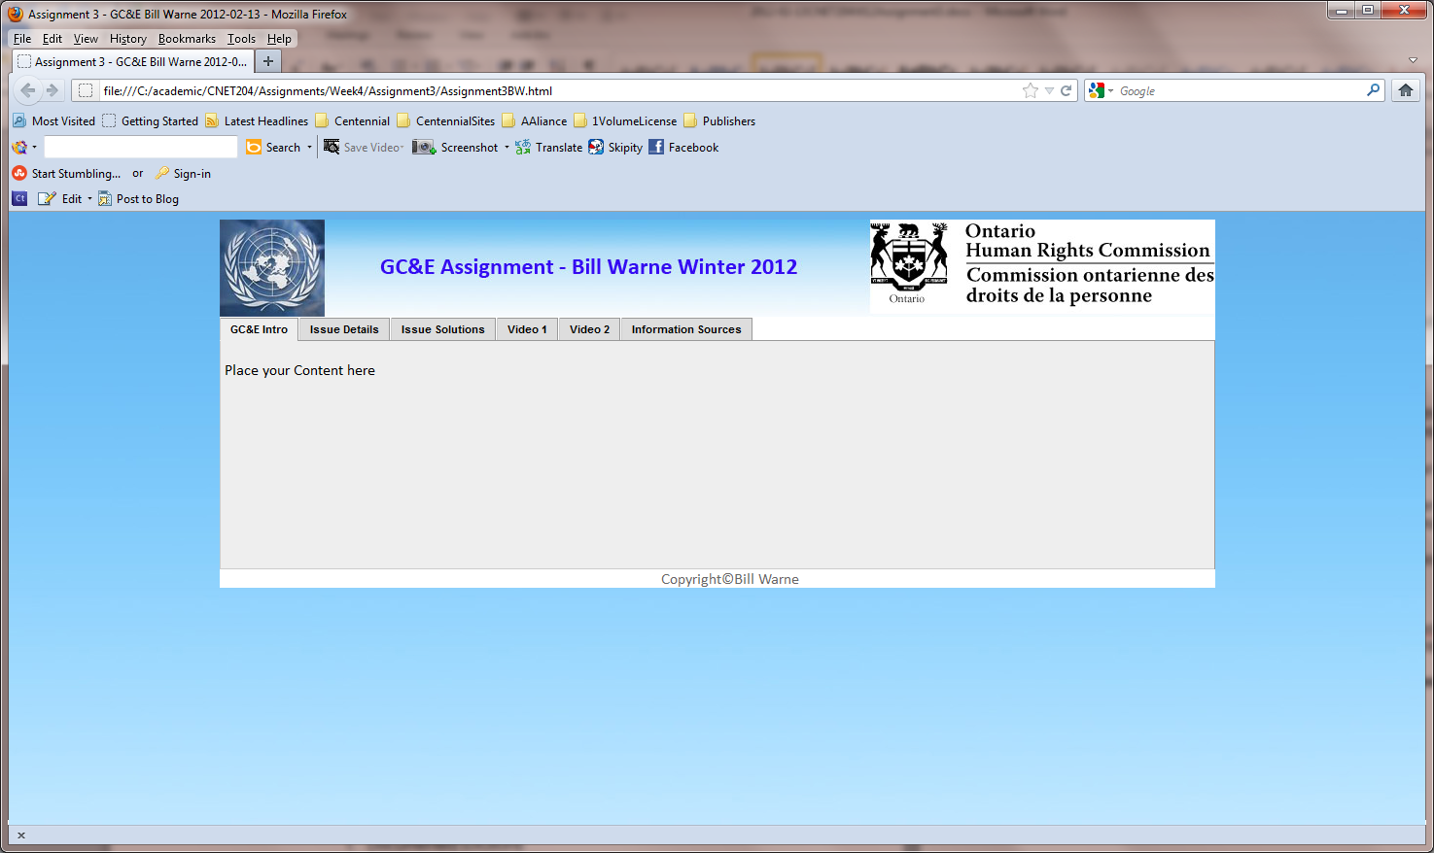

Follow these steps:

- Use Adobe CS4 to 6 of Dreamweaver to create your HTML document and PhotoShop to create your PageBackground1920X1080.jpg file and your TableBanner1024X100.jpg file.
- Choose appropriate font families (faces) that look similar to the sample (Hint: Arial, Helvetica, sans serif).
- Create an HTML comment within your document that shows your name, student number, course number, and section number.

- Put a proper Title for the page which includes your name

- Make the United Nations Logo in the Table Header you create go to the UN Human Rights Commission website. Include Alt text.

- Make the Ontario Human Rights Logo go to the Ontario Human rights commission website. Include Alt text.

- What are the 2 ways you can do this based on what you have learned this semester so far?

Upload your web page and support graphics to the studentweb server and provide an Assignment 3 hyperlink to it from your index.html home page.

This assignment is due at the end of the lab class next week. (I can see the date and time uploaded stats so don’t be late with this upload Due Wed. October 24th, 2012)

